Short questions
SSICTA1105_03A001E, 4
1. | A private gymnastics centre created a database for storing the information of trainers and members. Below is an incomplete ER diagram representing the relationship between the two tables.  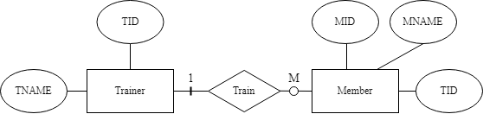
 | (a) | Write down the database schema of all tables. Identify all primary keys and foreign keys, if any.  (2 marks)  ________________________________________________________________________________  ________________________________________________________________________________  ________________________________________________________________________________
 | (b) | Describe the relationship represented by the ER diagram. (2 marks)  ________________________________________________________________________________  ________________________________________________________________________________

[--Answer:
(a) Trainer(TID, TNAME)
Primary key: TID Foreign key: N/A
Member (MID, MNAME, TID)
Primary key: MID Foreign key: TID

(b) The trainer in the gymnastics centre can train zero or more than one member, but a member must be trained by only one trainer.
--]

SSICTA1105_03A002E, 4
2. | The library uses two tables: BOOK and BORROWER to store information about books and the borrowing records.  BOOK  ISBN TITLE AUTHOR PUBLISHER  196448321 Second Chance Austin Lee Random House  563697413 New World Joseph Wong Modern-day  BORROWING_RECORD  BWID BWNAME ISBN  1 Natalie Yeung 196448321  2 Yvonne Tsang 563697413  3 Edison Lam 688775267
 | (a) | Assume that ISBN from BORROWING_RECORD is referencing ISBN from BOOK. Draw an ER diagram to represent the relationship between BOOK and BORROWING_RECORD. Attributes are not necessary. (3 marks)
 | (b) | Is there any potential anomaly when the book "New World" is deleted from the BOOK table? If yes, state the anomaly. (1 mark)  ________________________________________________________________________________

[--Answer:
(a)


(b) No.
--]
SSICTA1105_03B003E, 5
3. | Isaac is developing a weather data collection system that gathers temperature readings for various locations at different times throughout the day. The system includes two tables: LOCATION and DATA.  LOCATION  Field name Description  LID Identity code of each location  LOC Name of the location  DATA  Field name Description  LID Identity code of each location  DDATE Date of the weather data entry.  TIME Time of the weather data entry.  TEMP Temperature reading for the specified date and location.  Draft an ER diagram for the database design. Draw the attribute and underline the primary key.  (5 marks)

[--Answer:
(a)
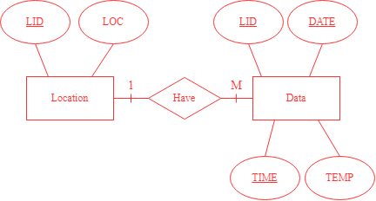
--]

SSICTA1105_03B004E, 3
4. | Miss Kwok, a class teacher at a primary school, is organising an in-class spelling competition. She uses a database table COMPETITION and TEAM to store information.  COMPETITION  Field name Description  RID Identity code of the round  T1 Class number of the student who is in Team 1  T1NAME Team name of Team 1  T2 Class number of the student who is in Team 2  T1NAME Team name of Team 2  QUESTION The word that needs to be spelt in this round  WINNER The student who wins this round  Here are all data on COMPETITION.  RID T1 T1NAME T2 T1NAME QUESTION WINNER  1 1 Wizards 2 Blaze Comics 1  2 3 Wizards 4 Blaze Airplane 4  3 5 Wizards 6 Blaze Scenario 5  4 7 Wizards 8 Blaze Illustrate 7
 | (a) | What is the candidate key of COMPETITION? (1 mark)  ________________________________________________________________________________
 | (b) | What kind of database anomaly will occur if Miss Kwok executes the following SQL command? Explain briefly. (2 marks)  UPDATE COMPETITION  SET T1NAME = 'New'  WHERE T1 = 1  ________________________________________________________________________________  ________________________________________________________________________________

[--Answer:
(a) RID
(b) Update anomaly will occur. In this case, the command updates the team name for Team 1 in the COMPETITION table. However, this update does not reflect in other rows where the same team participates.
--]

SSICTA1105_03B005E, 7
5. | Below is an ER diagram representing the relationship between members and albums in a music store.  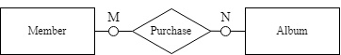
 | (a) | Resolve the above relationship into two one-to-many relationships. Attributes are not necessary.  (4 marks)
 | (b) | Describe the participation constraints and cardinalities of the relationship according to the ER diagram in (a). (2 marks)  ________________________________________________________________________________  ________________________________________________________________________________

[--Answer:
(a)

(b) Each member can purchase zero or multiple albums, and each purchase list is made by exactly one member. Each type of album can be not purchased or have many purchases, while every purchase list has only one album.
--]

SSICTA1105_03C006E, 4
6. | John has been given a project by a TV show streaming company. The company requires a robust database system to manage their streaming service efficiently. The project involves the following requirements:  - Watch list function  - The watch list will store the user’s history of watching TV shows  - A user can view zero or many TV shows, and a TV show can be watched by zero or many users  - Rating function  - A rating list will store users’ ratings of the TV shows  - A user may or may not rate a TV show, and a TV show may or may not be rated by a user
 | (a) | Referring to the requirements, complete the draft of the ER diagram for John below. It is not necessary to draw attributes in the diagram. (5 marks)

[--Answer:
(a)
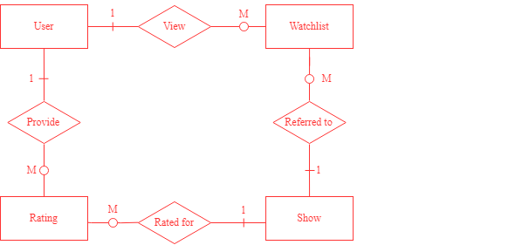
--]

SSICTA1105_03C007E, 7
7. | As a nurse, Vanessa viewed two database tables that store patient information. Below are the table structures of PATIENT and MEDICAL.  PATIENT  Field name Description  PID Identity code of each patient  PNAME Name of the patient  GENDER Gender of the patient  DOB Date of birth  MEDICAL  Field name Description  RID Identity code of the medical record  PID Identity code of each patient  DIAGNOSIS Diagnosis or medical condition assigned to the patient  TREATMENT Treatment or medical procedures provided to the patient  ALLERGIC Allergic reaction to some medicines  HISTORY Medical history of the patient  Below are some records of PATIENT and MEDICAL:  PID PNAME GENDER DOB  001 Jeffrey Man M 1997-08-08  002 Matthew Yip M 1990-01-30  RID PID DIAGNOSIS TREATMENT ALLERGIC HISTORY  1 001 Flu Rest Penicillin NULL  2 002 Sinusitis Antibiotics NULL Asthma, Diabetes
 | (a) | Write the schema for each table. Underline the primary key and identify the foreign key.  (4 marks)  ________________________________________________________________________________  ________________________________________________________________________________  ________________________________________________________________________________  ________________________________________________________________________________
 | (b) | Vanessa claims that the tables are in third normal form. Prove that her claim is wrong.  (3 marks)  ________________________________________________________________________________  ________________________________________________________________________________  ________________________________________________________________________________  ________________________________________________________________________________

[--Answer:
(a)
PATIENT (PID, PNAME, GENDER, DOB)
MEDICAL (RID, PID, DIAGNOSIS, TREATMENT, ALLERGIC, HISTORY)
Foreign key: PID

(b) Firstly, HISTORY may contain multiple values. Secondly, ALLERGIC and HISTORY depend on the non-key field PID rather than the primary key RID.

--]

Long questions
SSICTA1105_04A001E, 9
1. | A coffee brand that sources and sells different types of speciality coffee from around the world. They maintain a database table COFFEE to store information about the coffee they offer and the farm where it is produced.  COFFEE  Field name Description  CID Identity code of each coffee bean  CNAME Name of the coffee bean  FID Identity code of the farm where the coffee is produced  FARM The name of the farm where the coffee is produced  FRID Identity code of the farmer  FARMER The name of the farmer  Primary key: CID
 | (a) | A new coffee farm is collaborating with the brand, but they haven’t provided the coffee beans. However, the brand wishes to insert the data of the farm and farmers into the COFFEE table first. Explain why an insertion anomaly occurs. (2 marks)  ________________________________________________________________________________  ________________________________________________________________________________
 | (b) | What is the normalisation form of this table? Explain briefly. (2 marks)  ________________________________________________________________________________  ________________________________________________________________________________
 | (c) | Refer to the answer in (b), and normalise the table to the next normalisation form. Write the database schema for the tables, underline the primary key and identify the foreign key. (5 marks)  ________________________________________________________________________________  ________________________________________________________________________________  ________________________________________________________________________________
 | (d) | The requirements of the database are described below:  Each type of coffee bean has to be produced by exactly one farm. A farm can produce more than a kind of coffee bean. A farmer works in exactly one farm, and a farm includes many farmers.  Complete the ER diagram for the database design below. It is not necessary to draw attributes.  (3 marks)

[--Answer:
(a) Since the farm has not provided the coffee beans to the brand yet, the CID can only be NULL. While CID is the primary key of the COFFEE table and a primary key cannot be NULL, the record cannot be inserted.

(b) Second normal form (2NF). The table has no multi-value fields, repeating groups, or partial dependency. Yet, FARM depends on FID rather than depending directly on the primary key CID, which violates 3NF because of transitive functional dependency.

(c)
COFFEE (CID, CNAME, FID)
Foreign key: FID
FARM(FID, FARM_NAME)
FARMER(FRID, FARMER_NAME, FID)
Foreign key: FID

(d)
--]

SSICTA1105_04B002E, 8
2. | Below is a database table named PRODUCT and SELLING, which stores information on items sold in a grocery store.  PRODUCT  Field name Description  CID Identity code of the category  CATEGORY Category of the item  ITEM Name of the item  STOCK The stock of the item  Here are the data in this table.  CID CATEGORY ITEM STOCK  1 Fruit Apple 12  1 Fruit Banana 10  1 Fruit Orange 6  2 Seafood Shrimp 0  3 Dairy Cheese 19  3 Dairy Yoghurt 21  4 Vegetables Lettuce 11  SELLING  Field name Description  SID Identity code of each sale  ITEM The name of the item sold  QUANTITY The quantity of the item sold  SDATE The date of the sale  STIME The time of the sale  Here are the data in this table.  SID ITEM QUANTITY SDATE STIME  S01 Apple 5 2023-08-01 10:30 AM  S02 Yoghurt 1 2023-08-02 11:45 AM  S03 Shrimp 2 2023-08-02 02:15 PM  S04 Yoghurt 4 2023-08-03 09:30 AM  S05 Apple 3 2023-08-04 10:30 AM
 | (a) | Draw an ER diagram for the database design. It is not necessary to include the attributes.  (3 marks)
 | (b) | Joanna, the manager of this grocery store, would like to delete the following record in the PRODUCT table as it has already sold out.  CID CATEGORY ITEM STOCK  2 Seafood Shrimp 0  State the anomaly that occurs and explain it briefly. (2 marks)  ________________________________________________________________________________  ________________________________________________________________________________  ________________________________________________________________________________
 | (c) | Joanna usually searches for the items by category to facilitate data retrieval without changing the table structure. What should she do? (2 marks)  ________________________________________________________________________________  ________________________________________________________________________________

[--Answer:
(a)

(b) Deletion anomaly will occur. When Shrimp is deleted from the PRODUCT table, the data related to Shrimp, such as CATEGORY, will also be lost.

(c) Joanna should add an index on the CID/ CATEGORY column in the GROCERY table.
--]

SSICTA1105_04C003E, 13
3. | ABC School is creating a database to store information on students’ enrolment for courses.  Below is the table structure of STUDENT.  STUDENT  Field name Description  SID Identity code of student  SNAME Name of the student  CLASS Class of the student  CNO Student’s class number  COURSE1 First course enrolled by the student  COURSE2 Second course enrolled by the student  COURSE3 Third course enrolled by the student
 | (a) | Is STUDENT in first normal form (1NF)? Explain briefly. (2 marks)  ________________________________________________________________________________  ________________________________________________________________________________
 | (b) | Normalise the tables into a third normal form. You may need to create new fields to complete the schema below and underline the primary key. (5 marks)  STUDENT(_____________,_____________,_____________,_____________)  COURSE(______________,______________)  ENROLMENT(______________,______________)
 | (c) | The requirements of the database are described below:  Different courses are taught in one or several classrooms in ABC School. Each classroom is dedicated to one course only. All students must enrol in at least one course, every course should have more than one student, and one teacher must teach each course.  Complete the ER diagram below for the database. It is not necessary to draw attributes.  (6 marks)  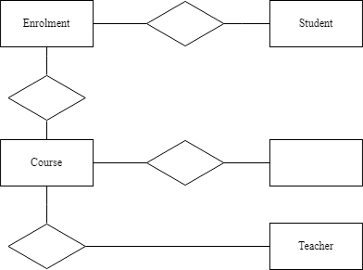

[--Answer:
(a)
No, COURSE1, COURSE2 and COURSE3 are a group of attributes storing the courses enrolled by students. They are the repeating attributes.

(b)
STUDENT (SID, SNAME, CLASS, CNO)
COURSE (CID, CNAME)
ENROLLMENT (CID, SID)

(c)



